**Batch: HO – ML 1 Experiment Number: 07**

**Roll Number: 16010422234 Name: Chandana Galgali**

**______________________________________________________________________________**

**Aim of the Experiment:** Describe the following points with respect to the business under consideration.

**Program/ Steps:**

1. Problem faced by the business

The system is designed such that it helps to estimate the price of a Car based upon the different features present, so it helps the business to give the correct amount of pricing to their Car Models, so that the customers are attracted and also are satisfied with the price range assigned based upon its features. So, assigning Price range accordingly is challenging without the use of ML algorithms.

2. Approach/ Methodology followed by the business

The methodology which we followed was that we took the dataset of Automobile Price Data. Then we split the dataset into train and test. Then we used Linear Regression and trained the machine learning model with that dataset and in the end we tested that model.

3. Skill Sets, infrastructure and other impact on the business during implementation

Skillset: Cloud computing

Infrastructure: Microsoft Azure Cloud services

There were no as such impacts on the business, as any of the business service lines were not being used.

4. Similar approaches followed by other businesses

Step 1. Sign-in using Microsoft account on studio.azureml.net

Step 2. Creating a workspace for our Machine Learning project.

Step 3. Select New option on bottom right:

Step 4. Click on Blank experiment and write name and summary of experiment

Step 5. Select From Saved Datasets-> Samples-> dataset of your choice

Step 6. Now, search ‘Select columns in dataset’ from items and drag it

Step 7. Now, click on launch column selector-> with rules->exclude column normalized-losses as that column contains many rows/records with empty values.

Step 8. Search and select ‘Clean Missing Data’ from items list

Step 9. Now, select cleaning mode -> Remove entire row as it will remove the entire row wherever missing value is found

Step 10. Again choose ‘select columns in dataset’

Step 11. Now, launch column selector and include all the columns based on which prediction is to be done: make, body-style, wheel-base, engine-size, horsepower, peak-rpm, highway-mpg, price

Step 12. Now, select ‘split data’ from list and drag it

Step 13. For Split data, enter the fraction of data which is needed for training while rest will be used for testing

Step 14. Now, Select ‘Linear Regression’ as the algorithm to be used and ‘Train Model’ from list

Step 15. For training model, click on launch column selector, include price column as Price is what is to be predicted

Step 16. Add Score Model from list drag it and make connections

Step 17. Now, Add Evaluate Model from list and make connections

Step 18. Now, Click on Run

Step 19. To check prediction results, right click on Score Model, select visualize

Step 20. To check Evaluation results, right click on Evaluation Model, select visualize

**Output/Result:**

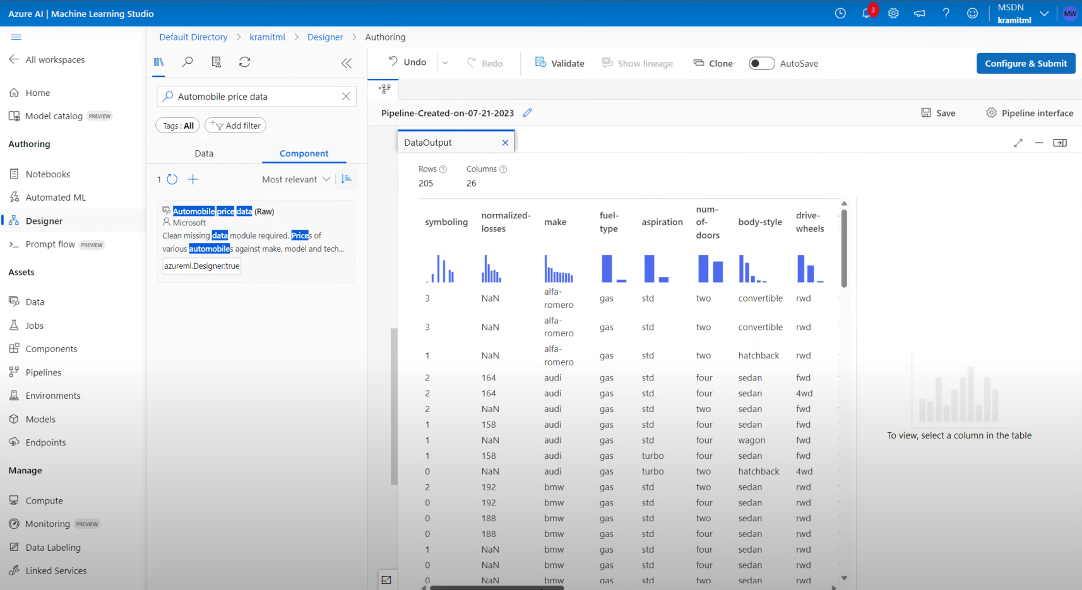

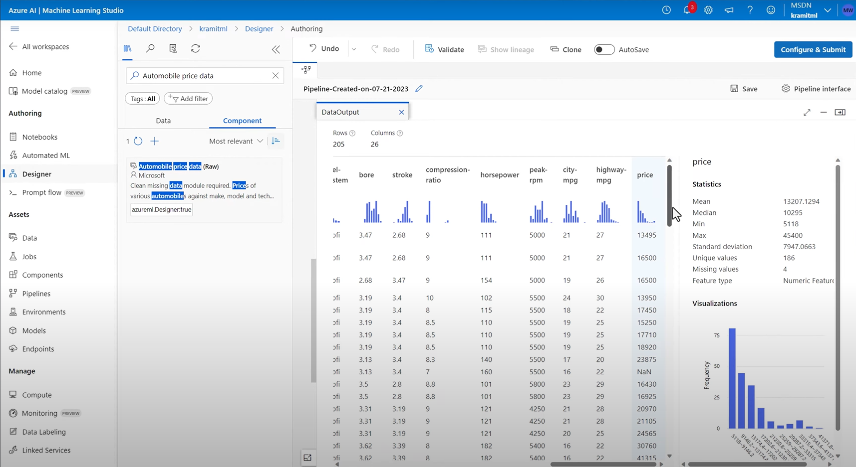

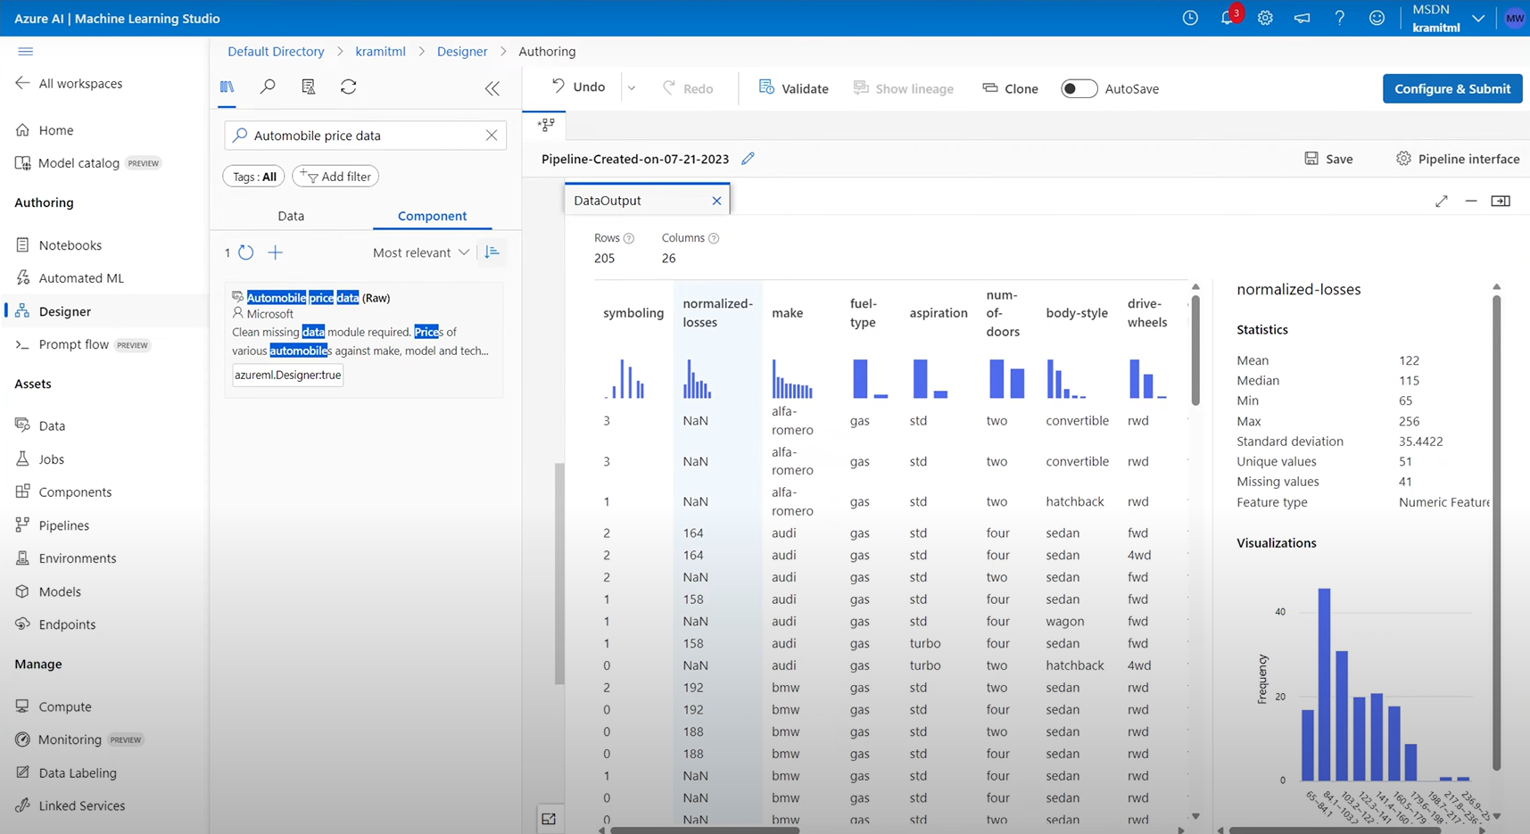

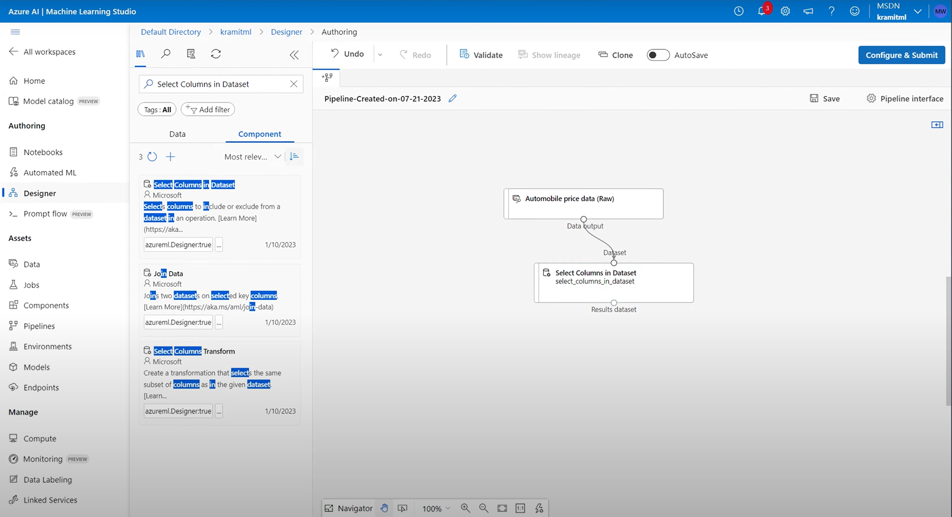

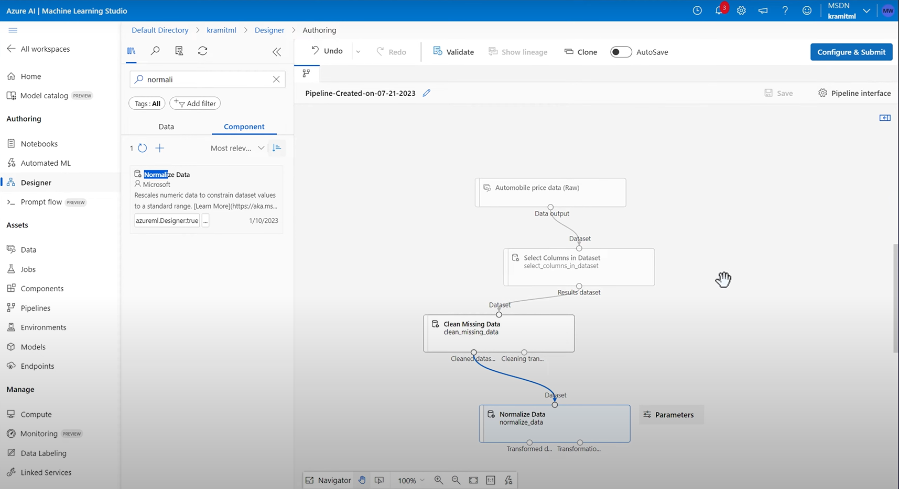

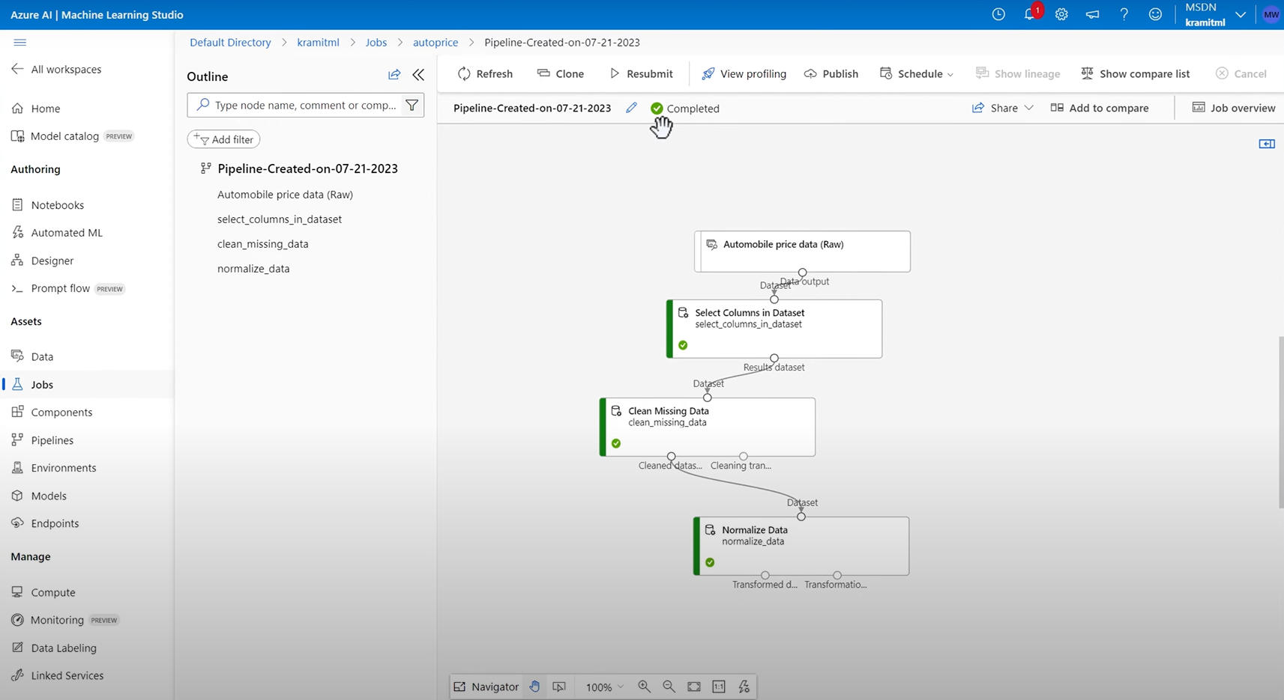

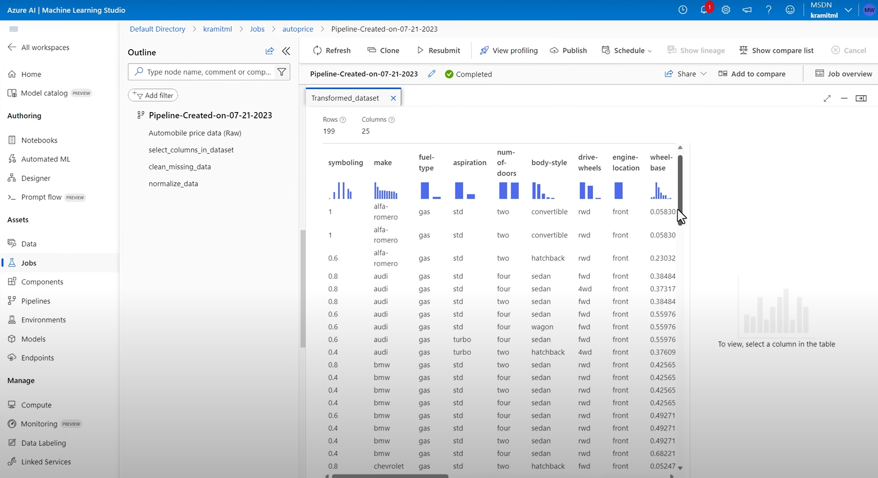

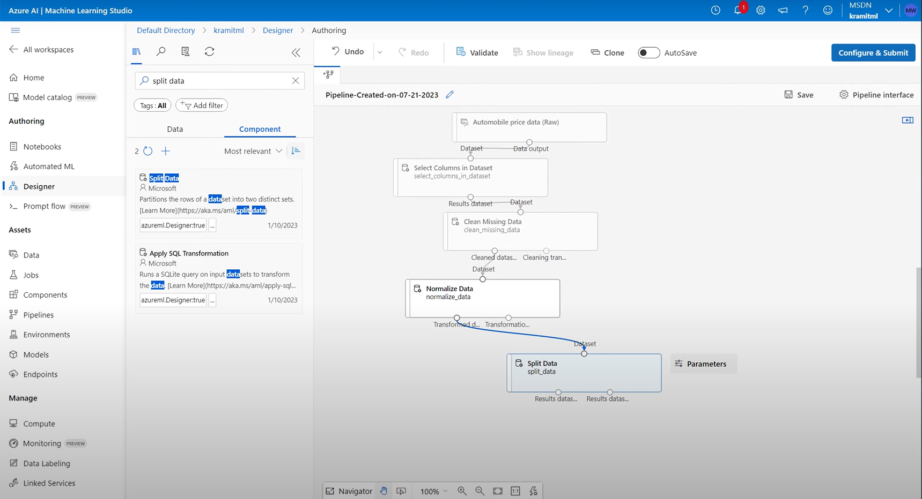

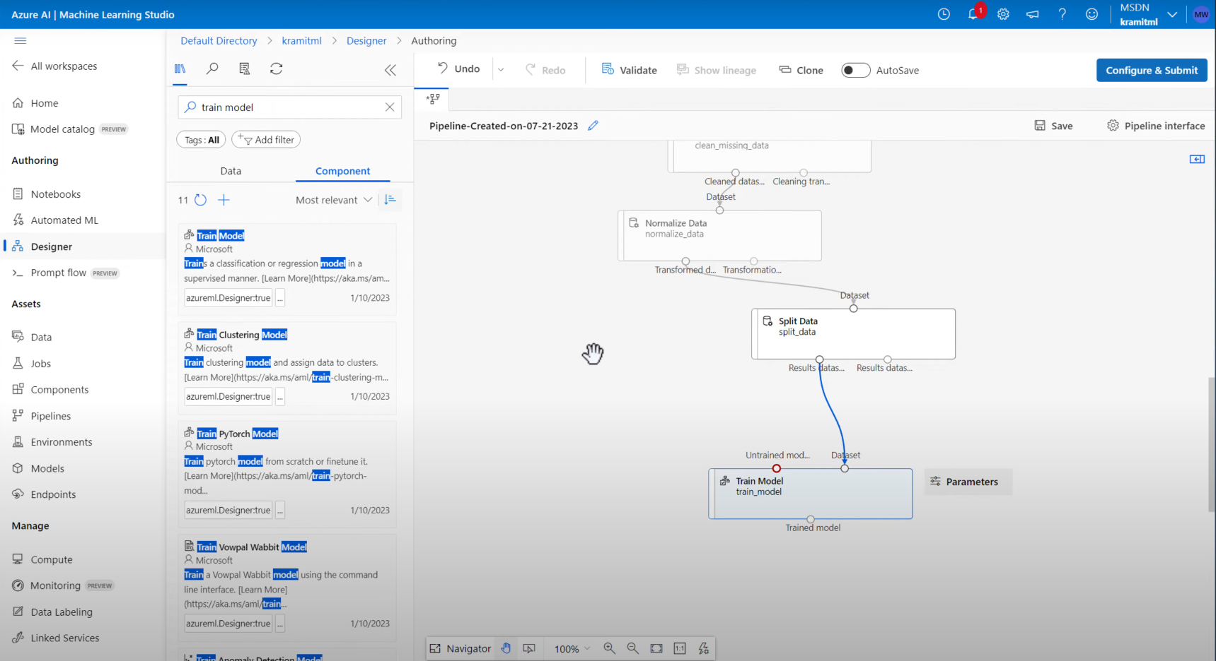

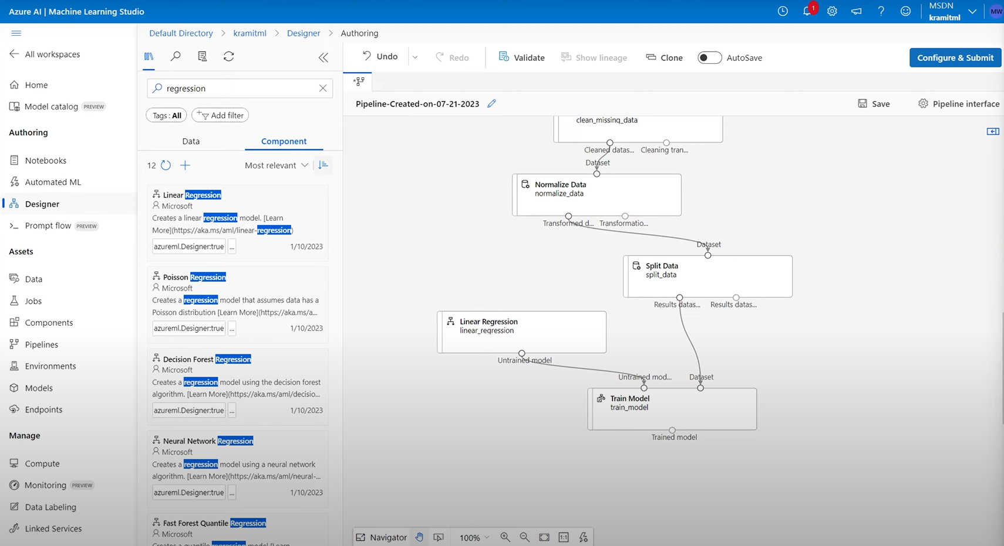

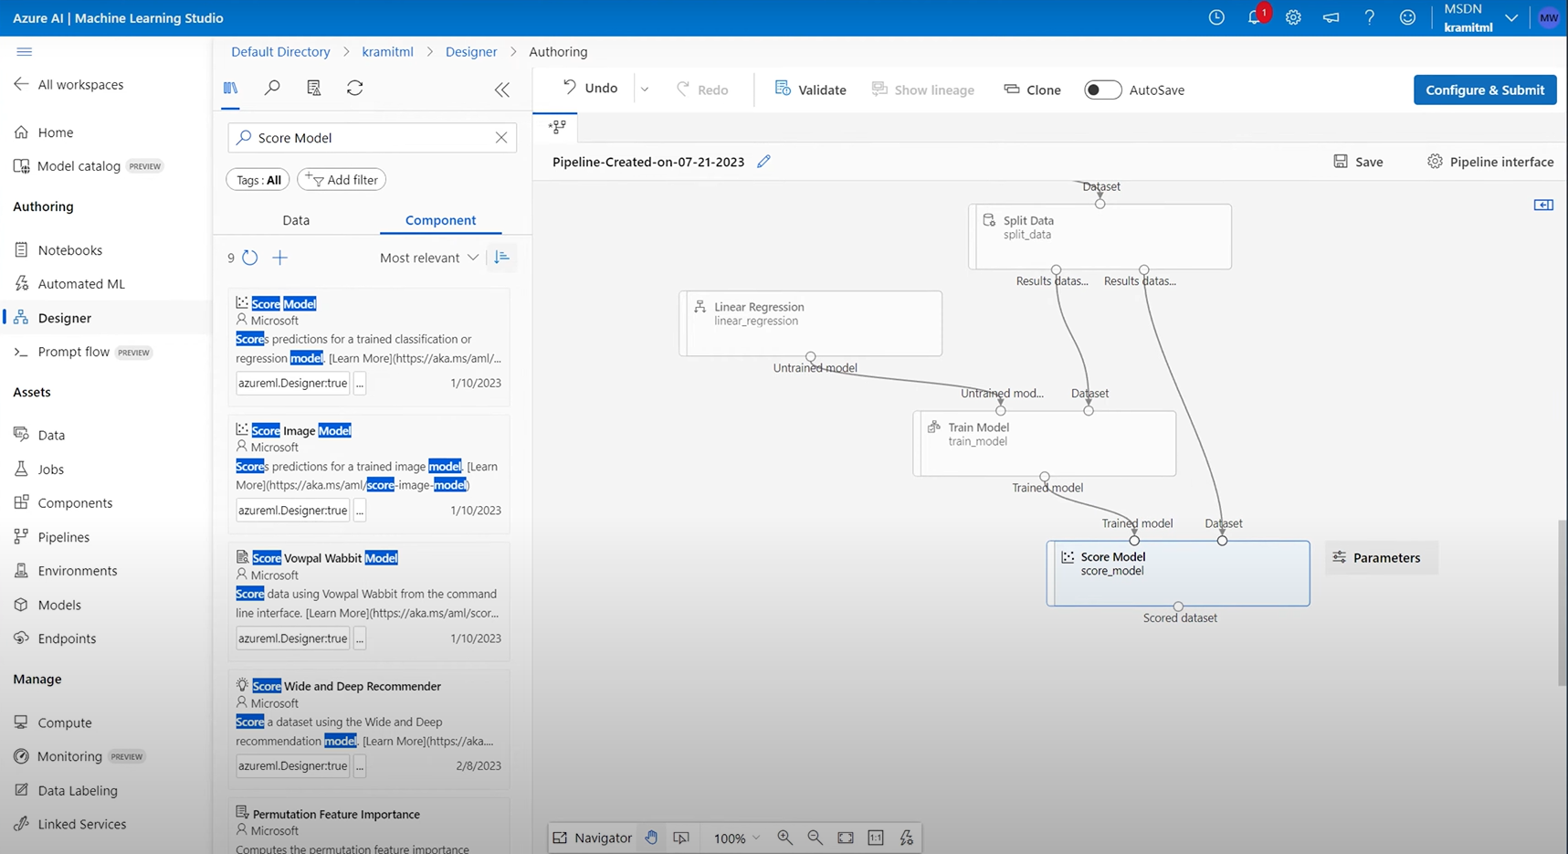

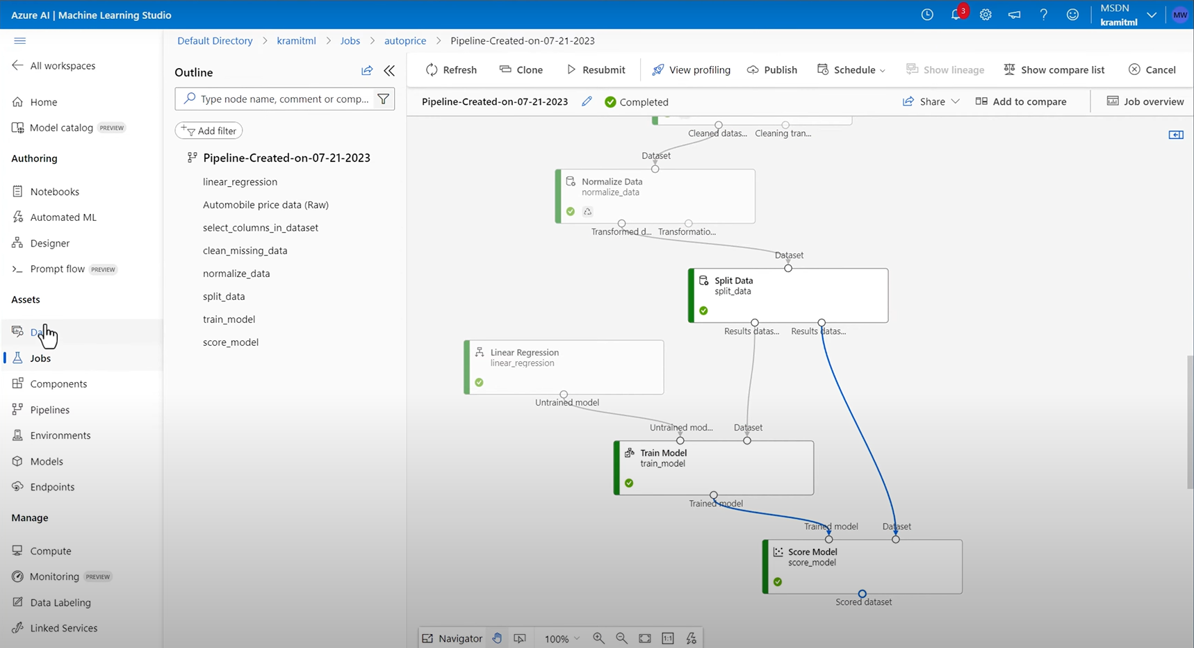

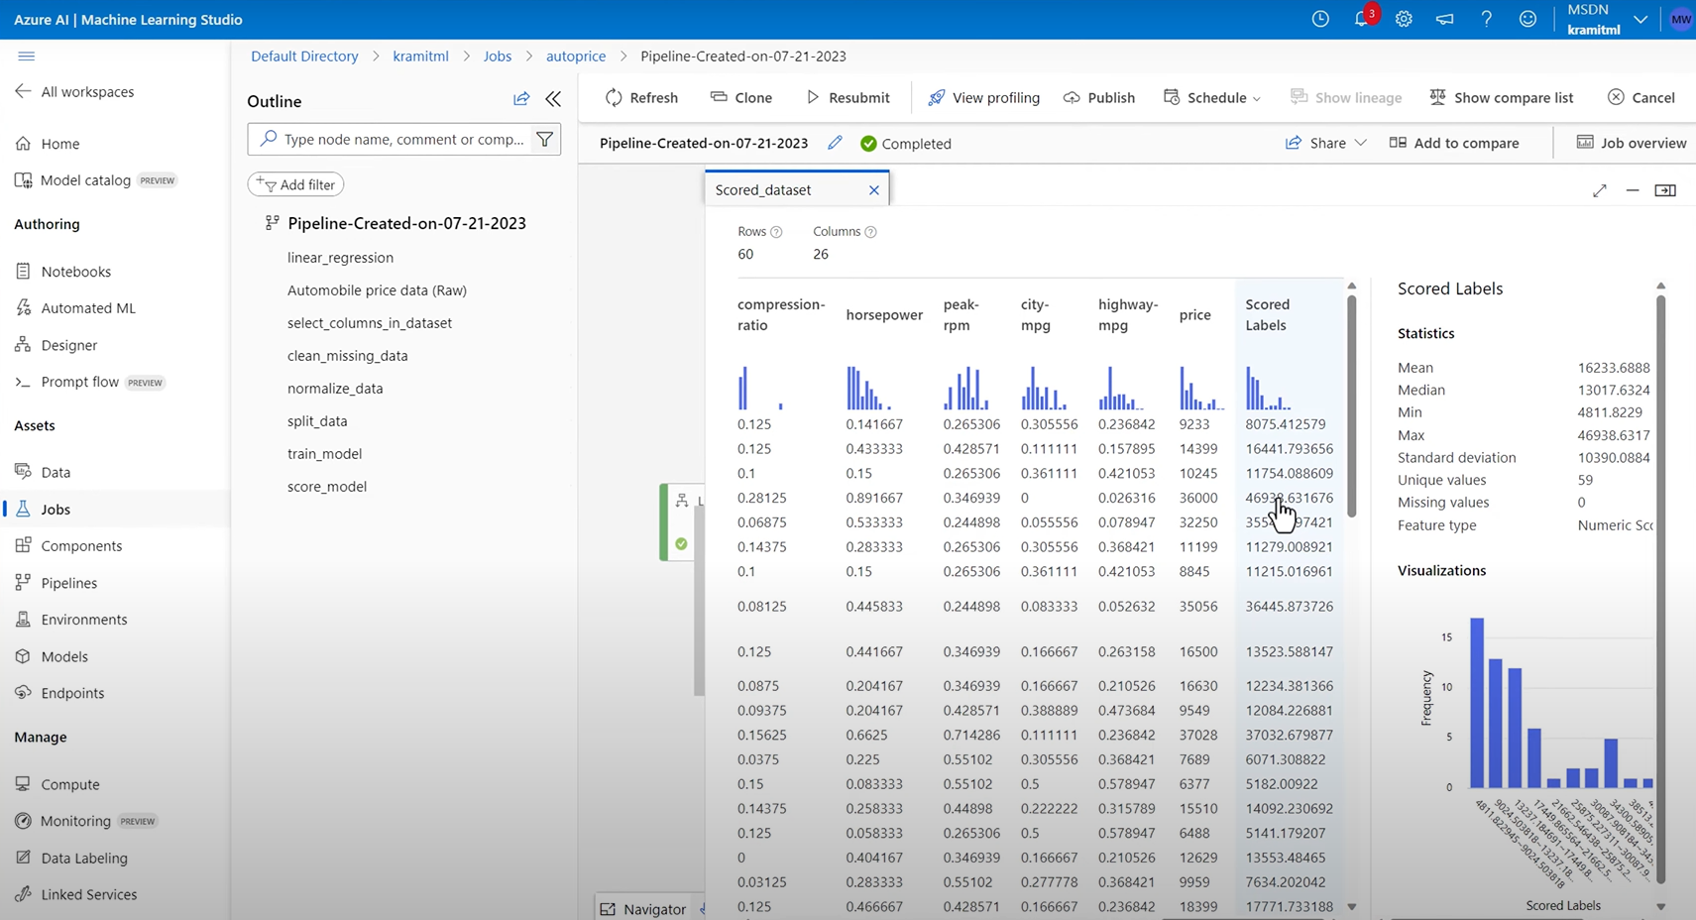

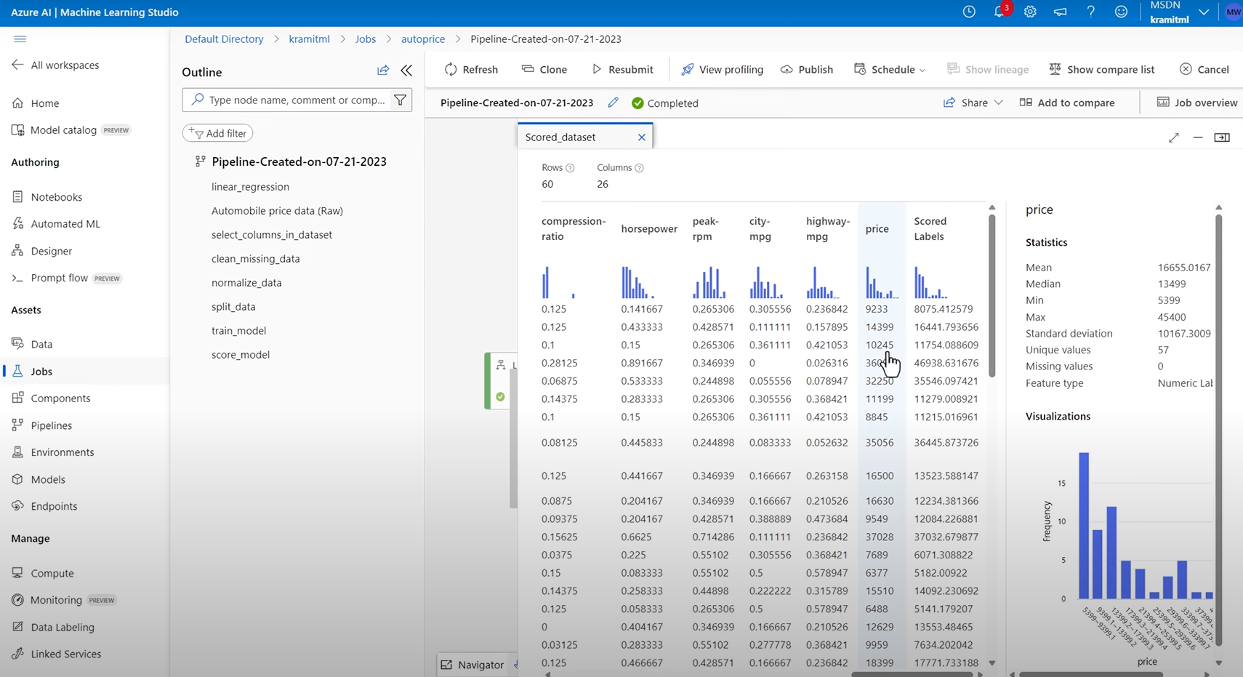

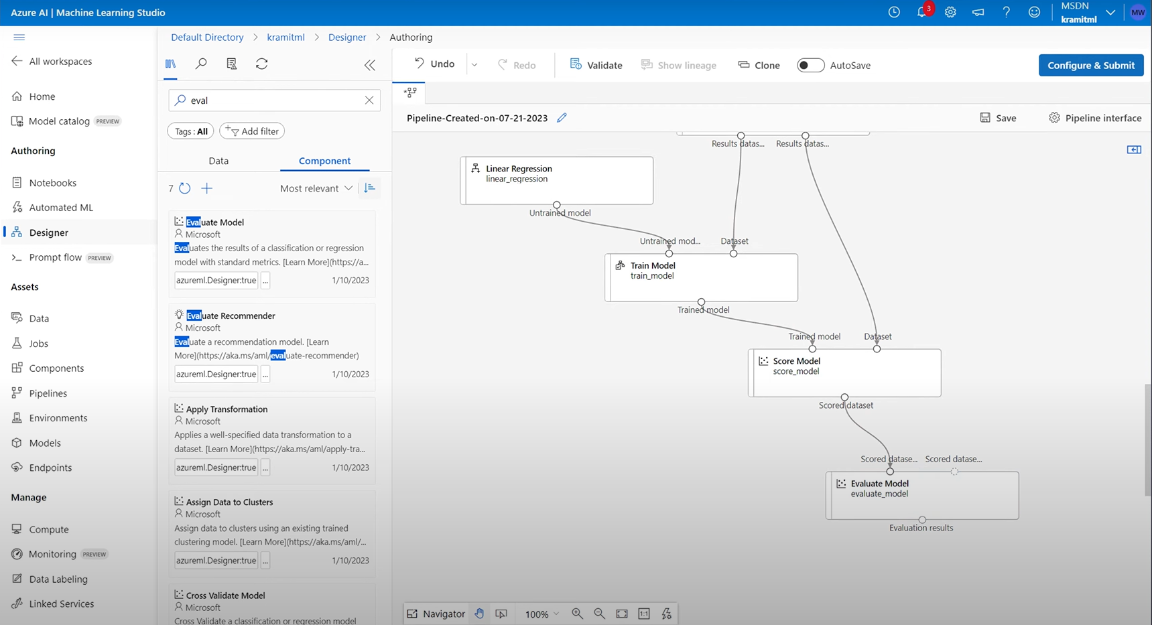

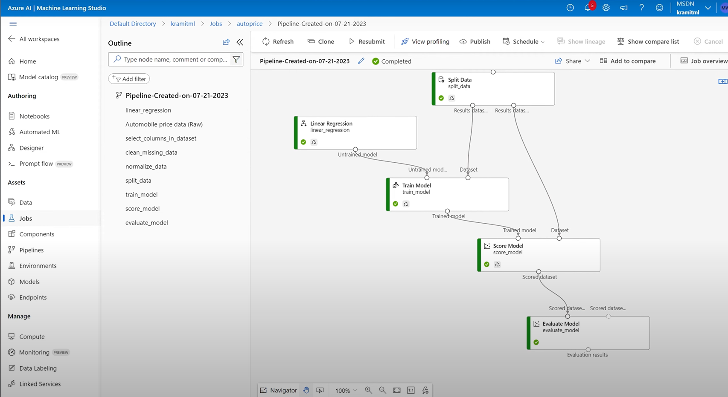

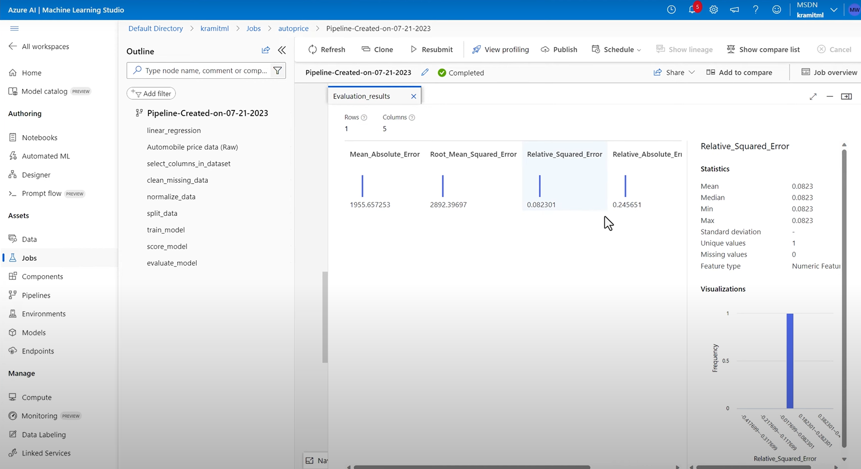

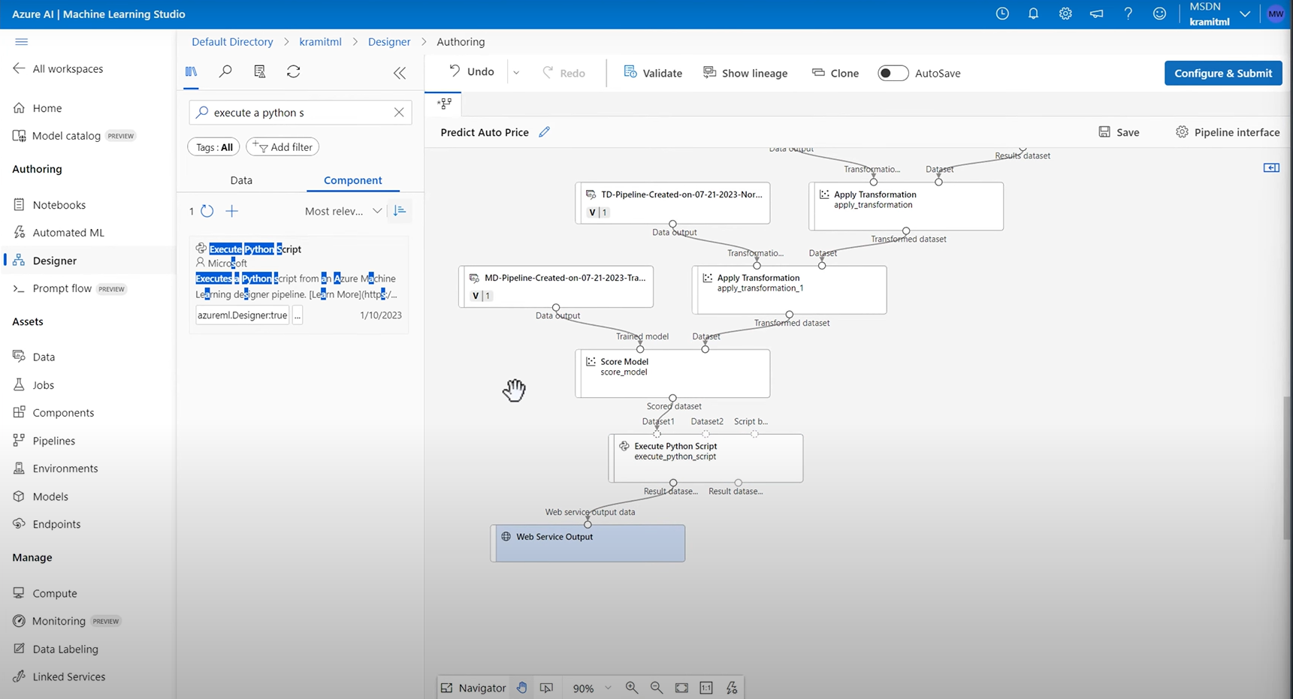

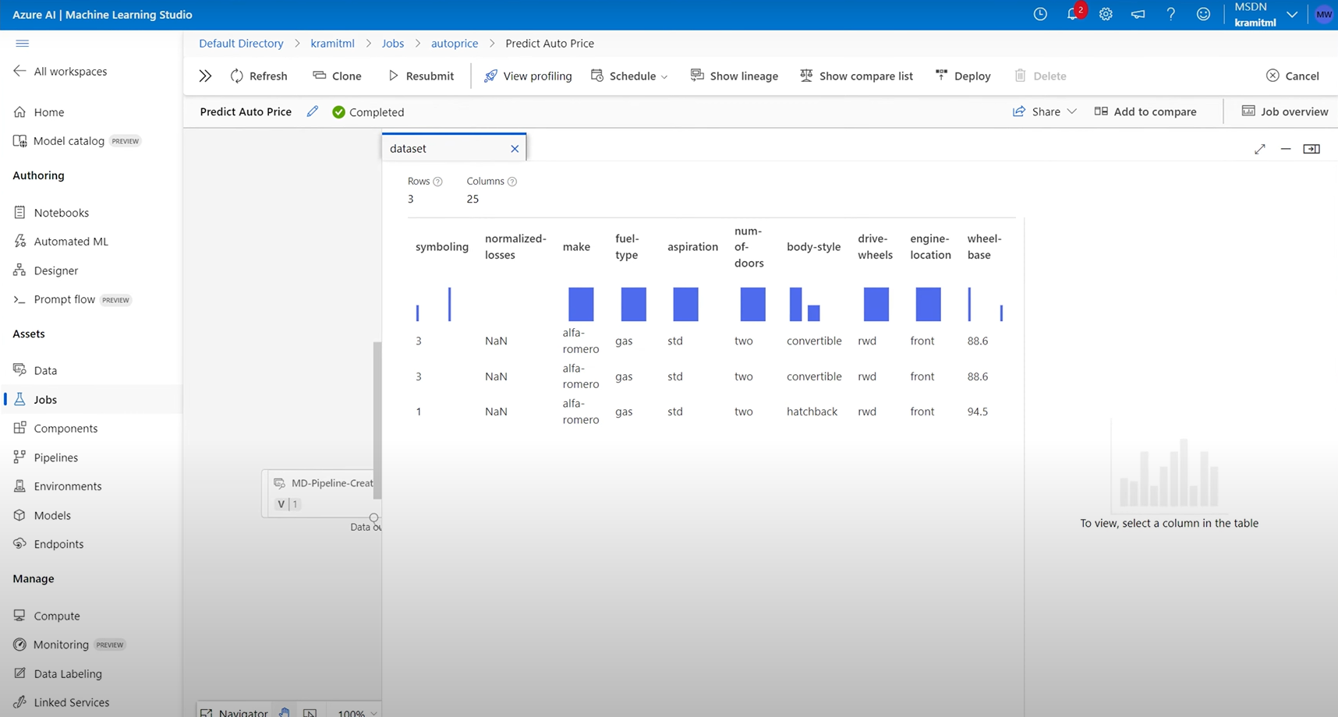

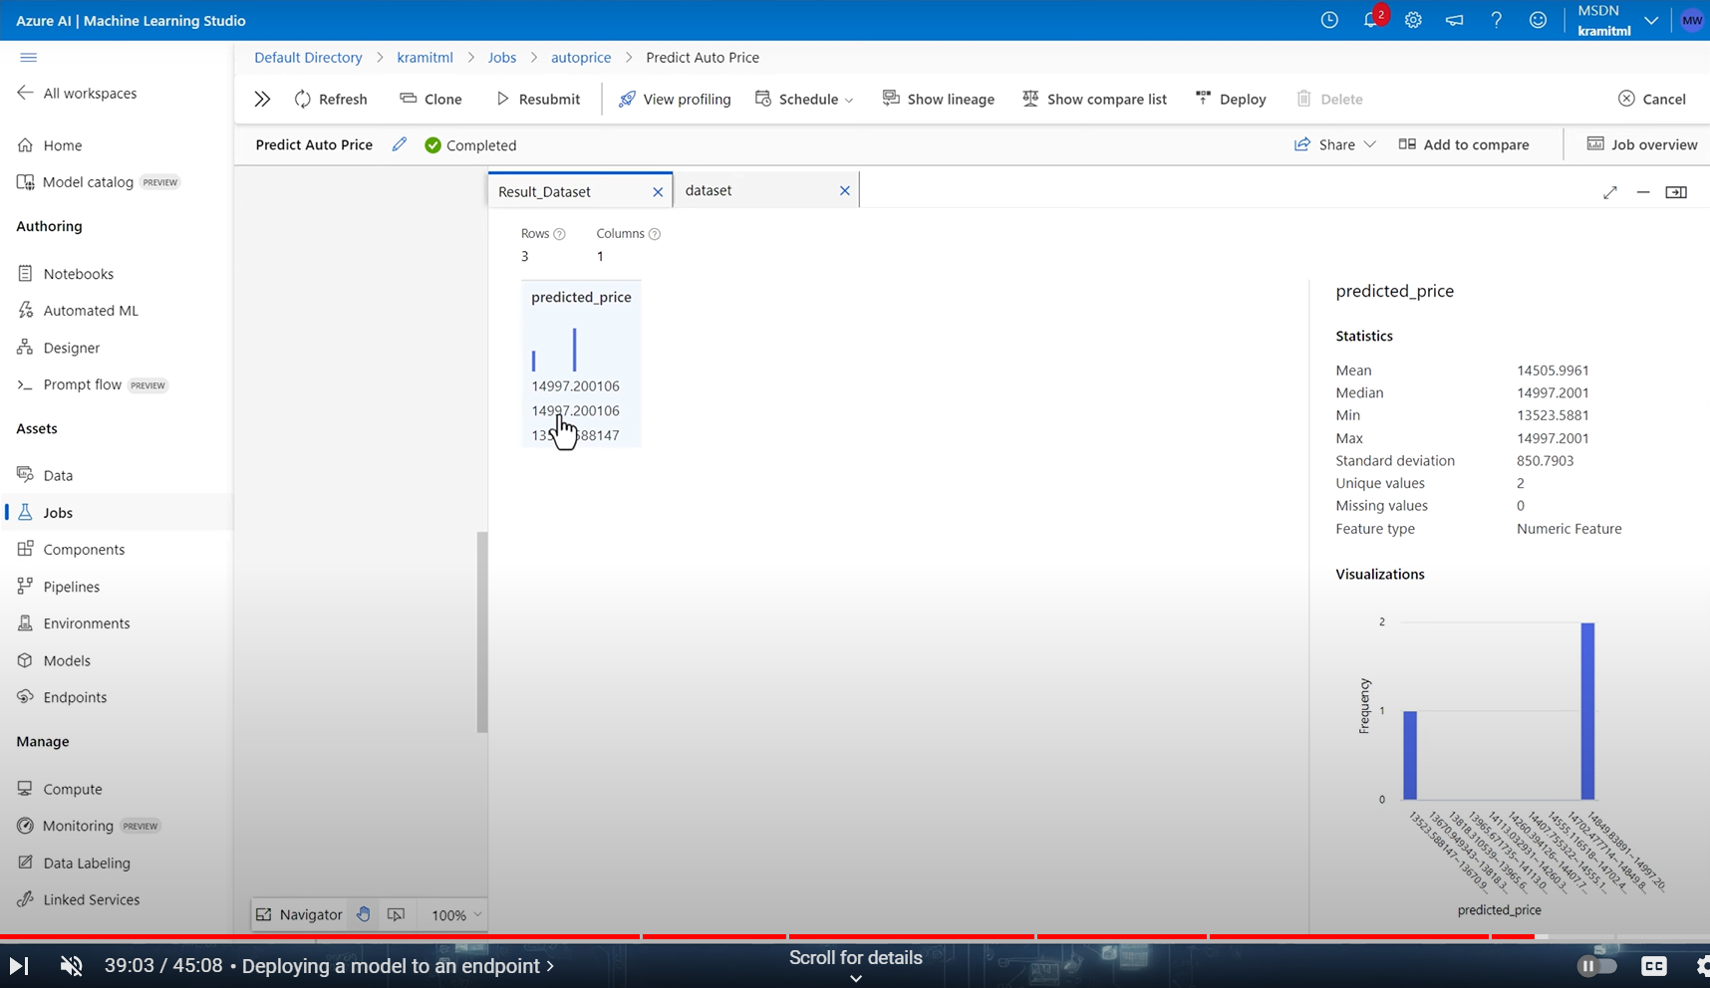

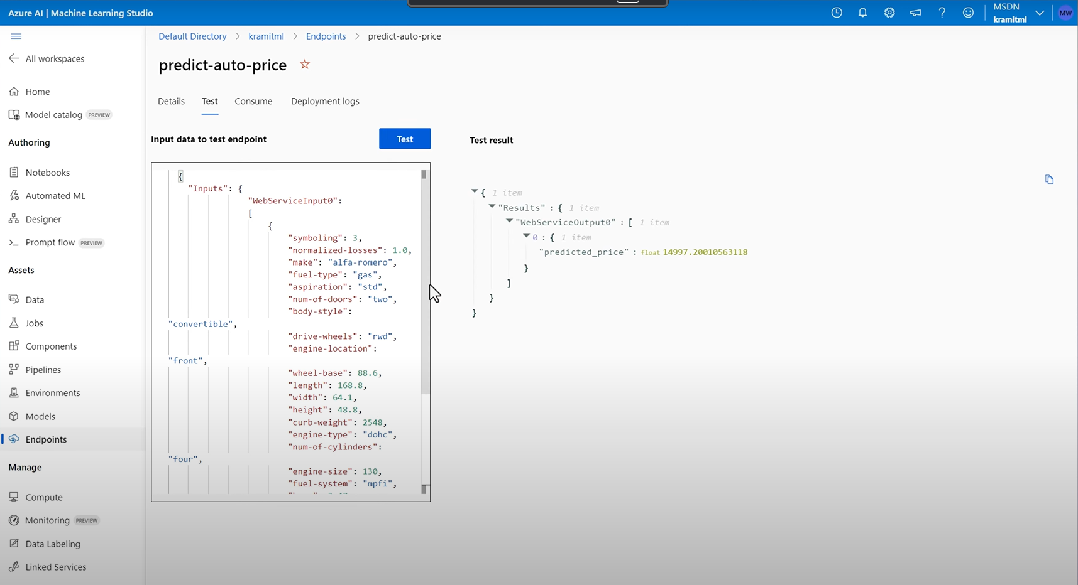

**Post Lab Question-Answers:**

**1. Differentiate between linear and nonlinear regression.**

Linear Regression: Assumes a linear relationship between the independent variables and the dependent variable. The model can be expressed in a straight-line formula (y = mx + b).

Nonlinear Regression: Involves modeling relationships that do not follow a straight line. It uses polynomial, exponential, or logarithmic functions to fit data that exhibits a more complex relationship.

**2. Write a note on converting non-linear models into linear models.**

Converting Non-linear Model into Linear Model Non-linear models can often be transformed into linear models through mathematical manipulation:

1) Transformation: Applying mathematical transformations to the variables (e.g., logarithmic or polynomial transformations) to achieve linearity.

2) Linearization: Using techniques such as Taylor series expansion to approximate non-linear relationships as linear over a limited range.

**Outcomes: Comprehend radial-basis-function (RBF) networks and Kernel learning method**

**Conclusion (based on the Results and outcomes achieved):**

The experiment effectively illustrated the use of machine learning to address a specific business challenge. By implementing a systematic approach that included data collection, model training, and evaluation, we demonstrated how predictive analytics can lead to more informed decision-making. This process not only enhances operational efficiency but also improves customer satisfaction, highlighting the importance of data-driven strategies in today’s competitive landscape.

**References:**

Books/ Journals/ Websites:

1. Han, Kamber, "Data Mining Concepts and Techniques", Morgan Kaufmann 3nd Edition

https://archive.ics.uci.edu/dataset/10/automobile